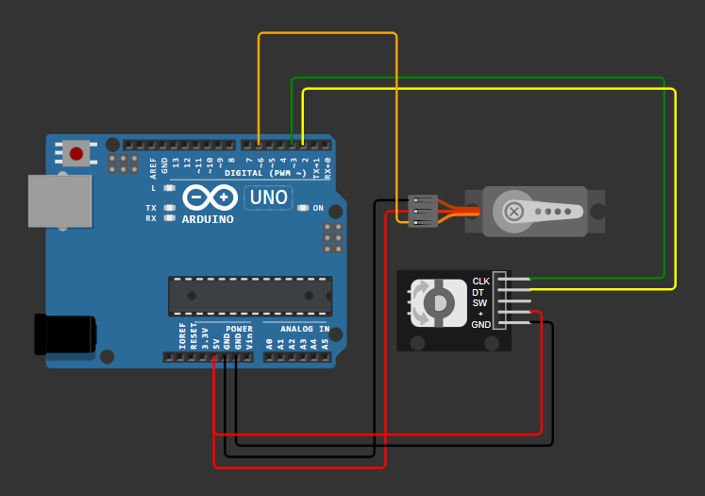
#include <Servo.h>

const int PinA = 3;
const int PinB = 2;
const int ServoPin = 6;

volatile int encoderPosition = 90;
volatile bool rotatingClockwise = true;

Servo myServo;

void setup() {
pinMode(PinA, INPUT_PULLUP);
pinMode(PinB, INPUT_PULLUP);

attachInterrupt(digitalPinToInterrupt(PinA), handleRotation, FALLING);

myServo.attach(ServoPin);
myServo.write(encoderPosition);

Serial.begin(9600);
}

void loop() {
static int lastReportedPosition = -1;

encoderPosition = constrain(encoderPosition, 0, 180);

if (lastReportedPosition != encoderPosition) {
myServo.write(encoderPosition);

Serial.print("Servo Position: ");
Serial.println(encoderPosition);

lastReportedPosition = encoderPosition;
}
}

void handleRotation() {
if (digitalRead(PinB) == HIGH) {
encoderPosition++;
} else {
encoderPosition--;
}
}

